Machine learning Life cycle

Machine learning has given the computer systems the abilities to automatically learn without being explicitly programmed. But how does a machine learning system work? So, it can be described using the life cycle of machine learning. Machine learning life cycle is a cyclic process to build an efficient machine learning project. The main purpose of the life cycle is to find a solution to the problem or project.

Machine learning life cycle involves seven major steps, which are given below:

* **Gathering Data**
* **Data preparation**
* **Data Wrangling**
* **Analyse Data**
* **Train the model**
* **Test the model**
* **Deployment**

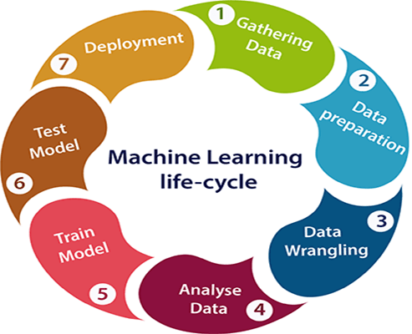

1. Gathering Data:

Data Gathering is the first step of the machine learning life cycle. The goal of this step is to identify and obtain all data-related problems.

In this step, we need to identify the different data sources, as data can be collected from various sources such as **files**, **database**, **internet**, or **mobile devices**. It is one of the most important steps of the life cycle. The quantity and quality of the collected data will determine the efficiency of the output. The more will be the data, the more accurate will be the prediction.

This step includes the below tasks:

* **Identify various data sources**
* **Collect data**
* **Integrate the data obtained from different sources**

By performing the above task, we get a coherent set of data, also called as a **dataset**. It will be used in further steps.

2. Data preparation

After collecting the data, we need to prepare it for further steps. Data preparation is a step where we put our data into a suitable place and prepare it to use in our machine learning training.

In this step, first, we put all data together, and then randomize the ordering of data.

This step can be further divided into two processes:

* **Data_exploration:**  
  It is used to understand the nature of data that we have to work with. We need to understand the characteristics, format, and quality of data. A better understanding of data leads to an effective outcome. In this, we find Correlations, general trends, and outliers.
* **Data_pre-processing:**  
  Now the next step is preprocessing of data for its analysis.

3. Data Wrangling

Data wrangling is the process of cleaning and converting raw data into a useable format. It is the process of cleaning the data, selecting the variable to use, and transforming the data in a proper format to make it more suitable for analysis in the next step. It is one of the most important steps of the complete process. Cleaning of data is required to address the quality issues.

It is not necessary that data we have collected is always of our use as some of the data may not be useful. In real-world applications, collected data may have various issues, including:

* **Missing Values**
* **Duplicate data**
* **Invalid data**
* **Noise**

So, we use various filtering techniques to clean the data.

It is mandatory to detect and remove the above issues because it can negatively affect the quality of the outcome.

4. Data Analysis

Now the cleaned and prepared data is passed on to the analysis step. This step involves:

* **Selection of analytical techniques**
* **Building models**
* **Review the result**

The aim of this step is to build a machine learning model to analyze the data using various analytical techniques and review the outcome. It starts with the determination of the type of the problems, where we select the machine learning techniques such as **Classification**, **Regression**, **Cluster analysis**, **Association**, etc. then build the model using prepared data, and evaluate the model.

Hence, in this step, we take the data and use machine learning algorithms to build the model.

5. Train Model

Now the next step is to train the model, in this step we train our model to improve its performance for better outcome of the problem.

We use datasets to train the model using various machine learning algorithms. Training a model is required so that it can understand the various patterns, rules, and, features.

6. Test Model

Once our machine learning model has been trained on a given dataset, then we test the model. In this step, we check for the accuracy of our model by providing a test dataset to it.

Testing the model determines the percentage accuracy of the model as per the requirement of project or problem.

7. Deployment

The last step of machine learning life cycle is deployment, where we deploy the model in the real-world system.

If the above-prepared model is producing an accurate result as per our requirement with acceptable speed, then we deploy the model in the real system. But before deploying the project, we will check whether it is improving its performance using available data or not. The deployment phase is similar to making the final report for a project.

Classification of Machine Learning

1. **Supervised learning**
2. **Unsupervised learning**
3. **Reinforcement learning**

Types of supervised Machine learning Algorithms:

Supervised learning can be further divided into two types of problems:

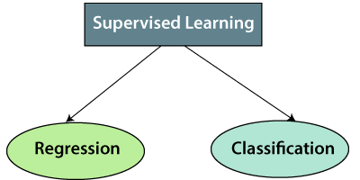

**1. Regression**

Regression algorithms are used if there is a relationship between the input variable and the output variable. It is used for the prediction of continuous variables, such as Weather forecasting, Market Trends, etc. Below are some popular Regression algorithms which come under supervised learning:

* Linear Regression
* Regression Trees
* Non-Linear Regression
* Bayesian Linear Regression
* Polynomial Regression

**2. Classification**

Classification algorithms are used when the output variable is categorical, which means there are two classes such as Yes-No, Male-Female, True-false, etc.

Spam Filtering,

* Random Forest
* Decision Trees
* Logistic Regression
* Support vector Machines

Advantages of Supervised learning:

* With the help of supervised learning, the model can predict the output on the basis of prior experiences.
* In supervised learning, we can have an exact idea about the classes of objects.
* Supervised learning model helps us to solve various real-world problems such as **fraud detection, spam filtering**, etc.

Disadvantages of supervised learning:

* Supervised learning models are not suitable for handling the complex tasks.
* Supervised learning cannot predict the correct output if the test data is different from the training dataset.
* Training required lots of computation times.
* In supervised learning, we need enough knowledge about the classes of object.

What is Unsupervised Learning?

As the name suggests, unsupervised learning is a machine learning technique in which models are not supervised using training dataset. Instead, models itself find the hidden patterns and insights from the given data. It can be compared to learning which takes place in the human brain while learning new things. It can be defined as:

Why use Unsupervised Learning?

Below are some main reasons which describe the importance of Unsupervised Learning:

* Unsupervised learning is helpful for finding useful insights from the data.
* Unsupervised learning is much similar as a human learns to think by their own experiences, which makes it closer to the real AI.
* Unsupervised learning works on unlabeled and uncategorized data which make unsupervised learning more important.
* In real-world, we do not always have input data with the corresponding output so to solve such cases, we need unsupervised learning.

Working of Unsupervised Learning

Working of unsupervised learning can be understood by the below diagram:

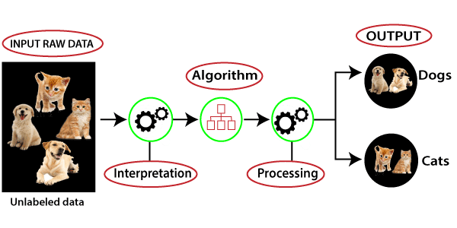

Here, we have taken an unlabeled input data, which means it is not categorized and corresponding outputs are also not given. Now, this unlabeled input data is fed to the machine learning model in order to train it. Firstly, it will interpret the raw data to find the hidden patterns from the data and then will apply suitable algorithms such as k-means clustering, Decision tree, etc.

Once it applies the suitable algorithm, the algorithm divides the data objects into groups according to the similarities and difference between the objects.

Types of Unsupervised Learning Algorithm:

The unsupervised learning algorithm can be further categorized into two types of problems:

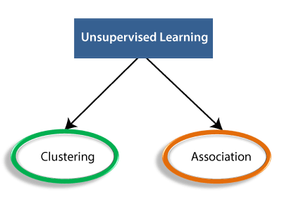

* **Clustering**: Clustering is a method of grouping the objects into clusters such that objects with most similarities remains into a group and has less or no similarities with the objects of another group. Cluster analysis finds the commonalities between the data objects and categorizes them as per the presence and absence of those commonalities.
* **Association**: An association rule is an unsupervised learning method which is used for finding the relationships between variables in the large database. It determines the set of items that occurs together in the dataset. Association rule makes marketing strategy more effective. Such as people who buy X item (suppose a bread) are also tend to purchase Y (Butter/Jam) item. A typical example of Association rule is Market Basket Analysis.

Note: We will learn these algorithms in later chapters.

Unsupervised Learning algorithms:

Below is the list of some popular unsupervised learning algorithms:

* **K-means clustering**
* **KNN (k-nearest neighbors)**
* **Hierarchal clustering**
* **Anomaly detection**
* **Neural Networks**
* **Principle Component Analysis**
* **Independent Component Analysis**
* **Apriori algorithm**
* **Singular value decomposition**

Advantages of Unsupervised Learning

* Unsupervised learning is used for more complex tasks as compared to supervised learning because, in unsupervised learning, we don't have labeled input data.
* Unsupervised learning is preferable as it is easy to get unlabeled data in comparison to labeled data.

Disadvantages of Unsupervised Learning

* Unsupervised learning is intrinsically more difficult than supervised learning as it does not have corresponding output.
* The result of the unsupervised learning algorithm might be less accurate as input data is not labeled, and algorithms do not know the exact output in advance.

|  |  |
| --- | --- |
| **Supervised Learning** | **Unsupervised Learning** |
| Supervised learning algorithms are trained using labeled data. | Unsupervised learning algorithms are trained using unlabeled data. |
| Supervised learning model takes direct feedback to check if it is predicting correct output or not. | Unsupervised learning model does not take any feedback. |
| Supervised learning model predicts the output. | Unsupervised learning model finds the hidden patterns in data. |
| In supervised learning, input data is provided to the model along with the output. | In unsupervised learning, only input data is provided to the model. |
| The goal of supervised learning is to train the model so that it can predict the output when it is given new data. | The goal of unsupervised learning is to find the hidden patterns and useful insights from the unknown dataset. |
| Supervised learning needs supervision to train the model. | Unsupervised learning does not need any supervision to train the model. |
| Supervised learning can be categorized in **Classification** and **Regression** problems. | Unsupervised Learning can be classified in **Clustering** and **Associations** problems. |
| Supervised learning can be used for those cases where we know the input as well as corresponding outputs. | Unsupervised learning can be used for those cases where we have only input data and no corresponding output data. |
| Supervised learning model produces an accurate result. | Unsupervised learning model may give less accurate result as compared to supervised learning. |
| Supervised learning is not close to true Artificial intelligence as in this, we first train the model for each data, and then only it can predict the correct output. | Unsupervised learning is more close to the true Artificial Intelligence as it learns similarly as a child learns daily routine things by his experiences. |
| It includes various algorithms such as Linear Regression, Logistic Regression, Support Vector Machine, Multi-class Classification, Decision tree, Bayesian Logic, etc. | It includes various algorithms such as Clustering, KNN, and Apriori algorithm. |

**SUPERVISED MACHINE LEARNING**

Regression Analysis in Machine learning

Regression analysis is a statistical method to model the relationship between a dependent (target) and independent (predictor) variables with one or more independent variables. More specifically, Regression analysis helps us to understand how the value of the dependent variable is changing corresponding to an independent variable when other independent variables are held fixed. It predicts continuous/real values such as **temperature, age, salary, price,** etc.

**Example:** Suppose there is a marketing company A, who does various advertisement every year and get sales on that. The below list shows the advertisement made by the company in the last 5 years and the corresponding sales:

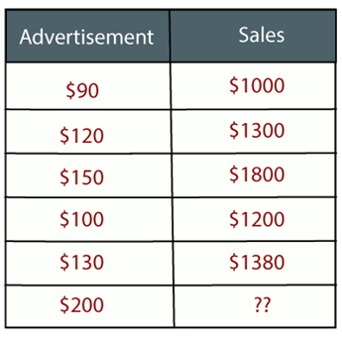

Now, the company wants to do the advertisement of $200 in the year 2019 **and wants to know the prediction about the sales for this year**. So to solve such type of prediction problems in machine learning, we need regression analysis.

Regression is a [supervised learning technique](https://www.javatpoint.com/supervised-machine-learning) which helps in finding the correlation between variables and enables us to predict the continuous output variable based on the one or more predictor variables. It is mainly used for **prediction, forecasting, time series modeling, and determining the causal-effect relationship between variables**.

In Regression, we plot a graph between the variables which best fits the given datapoints, using this plot, the machine learning model can make predictions about the data. In simple words, ***"Regression shows a line or curve that passes through all the datapoints on target-predictor graph in such a way that the vertical distance between the datapoints and the regression line is minimum."***

Some examples of regression can be as:

* Prediction of rain using temperature and other factors
* Determining Market trends
* Prediction of road accidents due to rash driving.

Terminologies Related to the Regression Analysis:

* **Dependent Variable:** The main factor in Regression analysis which we want to predict or understand is called the dependent variable. It is also called **target variable**.
* **Independent Variable:** The factors which affect the dependent variables or which are used to predict the values of the dependent variables are called independent variable, also called as a **predictor**.
* **Outliers:** Outlier is an observation which contains either very low value or very high value in comparison to other observed values. An outlier may hamper the result, so it should be avoided.
* **Multicollinearity:** If the independent variables are highly correlated with each other than other variables, then such condition is called Multicollinearity. It should not be present in the dataset, because it creates problem while ranking the most affecting variable.
* **Underfitting and Overfitting:** If our algorithm works well with the training dataset but not well with test dataset, then such problem is called **Overfitting**. And if our algorithm does not perform well even with training dataset, then such problem is called **underfitting**.

Types of Regression

There are various types of regressions which are used in data science and machine learning. Each type has its own importance on different scenarios, but at the core, all the regression methods analyze the effect of the independent variable on dependent variables.

* **Linear Regression**
* **Logistic Regression**
* **Polynomial Regression**
* **Support Vector Regression**
* **Decision Tree Regression**
* **Random Forest Regression**
* **Ridge Regression**
* **Lasso Regression:**

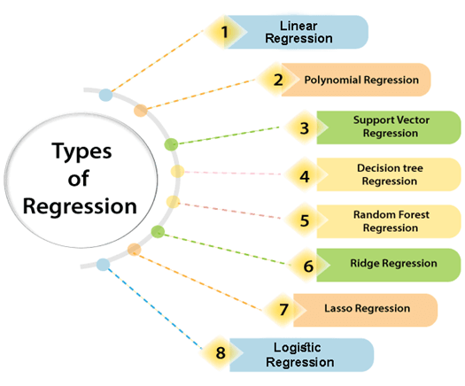

Linear Regression:

* Linear regression is a statistical regression method which is used for predictive analysis.
* It is one of the very simple and easy algorithms which works on regression and shows the relationship between the continuous variables.
* It is used for solving the regression problem in machine learning.
* Linear regression shows the linear relationship between the independent variable (X-axis) and the dependent variable (Y-axis), hence called linear regression.
* If there is only one input variable (x), then such linear regression is called **simple linear regression**. And if there is more than one input variable, then such linear regression is called **multiple linear regression**.
* The relationship between variables in the linear regression model can be explained using the below image. Here we are predicting the salary of an employee on the basis of **the year of experience**.

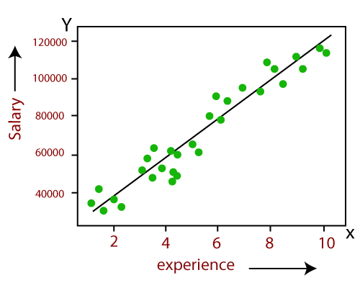

* Below is the mathematical equation for Linear regression:

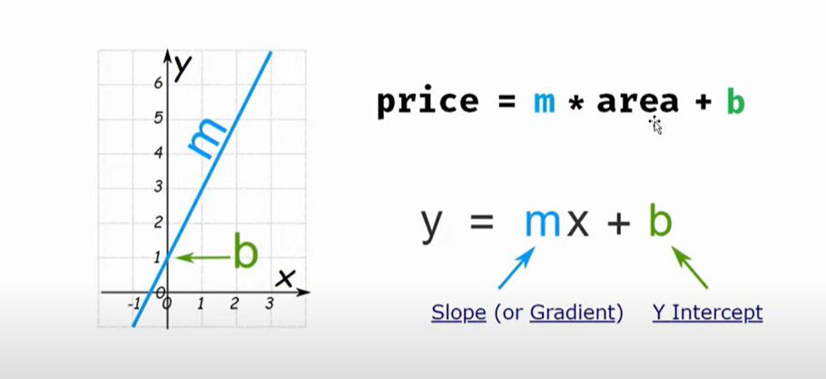

1. **Y= mx+b**

**Here,Y=dependent_variables_(target_variables),**  
**X= Independent variables (predictor variables),a and b are the linear coefficients**

Some popular applications of linear regression are:

* **Analyzing trends and sales estimates**
* **Salary forecasting**
* **Real estate prediction**
* **Arriving at ETAs in traffic.**

Logistic Regression:

* Logistic regression is another supervised learning algorithm which is used to solve the classification problems. In **classification problems**, we have dependent variables in a binary or discrete format such as 0 or 1.
* Logistic regression algorithm works with the categorical variable such as 0 or 1, Yes or No, True or False, Spam or not spam, etc.
* It is a predictive analysis algorithm which works on the concept of probability.
* Logistic regression is a type of regression, but it is different from the linear regression algorithm in the term how they are used.
* Logistic regression uses **sigmoid function** or logistic function which is a complex cost function. This sigmoid function is used to model the data in logistic regression. The function can be represented as:

Regression Analysis in Machine learning

* f(x)= Output between the 0 and 1 value.
* x= input to the function
* e= base of natural logarithm.

When we provide the input values (data) to the function, it gives the S-curve as follows:

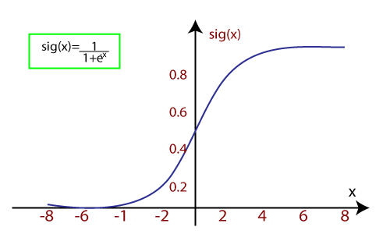

* It uses the concept of threshold levels, values above the threshold level are rounded up to 1, and values below the threshold level are rounded up to 0.

There are three types of logistic regression:

* **Binary(0/1, pass/fail)**
* **Multi(cats, dogs, lions)**
* **Ordinal(low, medium, high)**

Polynomial Regression:

* Polynomial Regression is a type of regression which models the **non-linear dataset** using a linear model.
* It is similar to multiple linear regression, but it fits a non-linear curve between the value of x and corresponding conditional values of y.
* Suppose there is a dataset which consists of datapoints which are present in a non-linear fashion, so for such case, linear regression will not best fit to those datapoints. To cover such datapoints, we need Polynomial regression.
* I**n Polynomial regression, the original features are transformed into polynomial features of given degree and then modeled using a linear model.** Which means the datapoints are best fitted using a polynomial line.

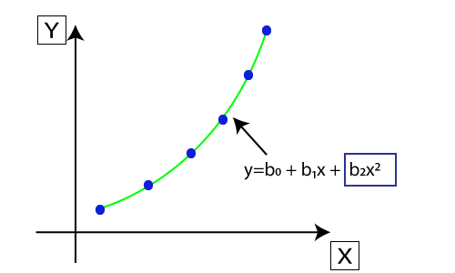

* The equation for polynomial regression also derived from linear regression equation that means Linear regression equation Y= b0+ b1x, is transformed into Polynomial regression equation Y= b0+b1x+ b2x2+ b3x3+.....+ bnxn.
* Here Y is the **predicted/target output, b0, b1,... bn are the regression coefficients**. x is our **independent/input variable**.
* The model is still linear as the coefficients are still linear with quadratic

**Note:** This is different from Multiple Linear regression in such a way that in Polynomial regression, a single element has different degrees instead of multiple variables with the same degree.

Support Vector Regression:

Support Vector Machine is a supervised learning algorithm which can be used for regression as well as classification problems. So if we use it for regression problems, then it is termed as Support Vector Regression.

Support Vector Regression is a regression algorithm which works for continuous variables. Below are some keywords which are used in **Support Vector Regression**:

* **Kernel:** It is a function used to map a lower-dimensional data into higher dimensional data.
* **Hyperplane:** In general SVM, it is a separation line between two classes, but in SVR, it is a line which helps to predict the continuous variables and cover most of the datapoints.
* **Boundary line:** Boundary lines are the two lines apart from hyperplane, which creates a margin for datapoints.
* **Support vectors:** Support vectors are the datapoints which are nearest to the hyperplane and opposite class.

In SVR, we always try to determine a hyperplane with a maximum margin, so that maximum number of datapoints are covered in that margin. ***The main goal of SVR is to consider the maximum datapoints within the boundary lines and the hyperplane (best-fit line) must contain a maximum number of datapoints***. Consider the below image:

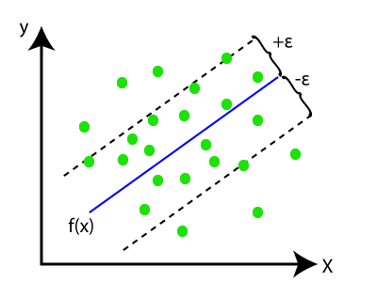

Here, the blue line is called hyperplane, and the other two lines are known as boundary lines.

Decision Tree Regression:

* Decision Tree is a supervised learning algorithm which can be used for solving both classification and regression problems.
* It can solve problems for both categorical and numerical data
* Decision Tree regression builds a tree-like structure in which each internal node represents the "test" for an attribute, each branch represent the result of the test, and each leaf node represents the final decision or result.
* A decision tree is constructed starting from the root node/parent node (dataset), which splits into left and right child nodes (subsets of dataset). These child nodes are further divided into their children node, and themselves become the parent node of those nodes. Consider the below image:

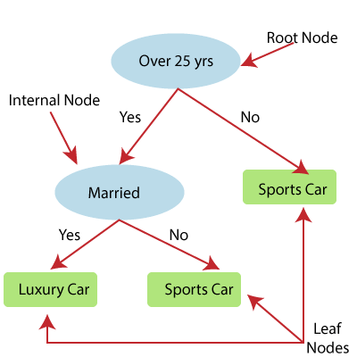

Above image showing the example of Decision Tee regression, here, the model is trying to predict the choice of a person between Sports cars or Luxury car.

* Random forest is one of the most powerful supervised learning algorithms which is capable of performing regression as well as classification tasks.
* The Random Forest regression is an ensemble learning method which combines multiple decision trees and predicts the final output based on the average of each tree output. The combined decision trees are called as base models, and it can be represented more formally as:

g(x)= f0(x)+ f1(x)+ f2(x)+....

* Random forest uses **Bagging or Bootstrap Aggregation** technique of ensemble learning in which aggregated decision tree runs in parallel and do not interact with each other.
* With the help of Random Forest regression, we can prevent Overfitting in the model by creating random subsets of the dataset.

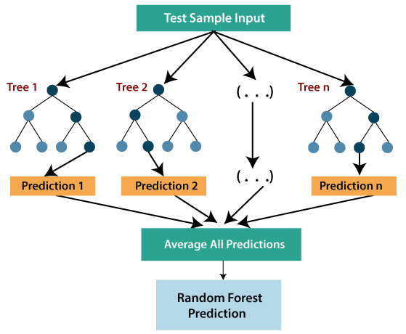

Ridge Regression:

* Ridge regression is one of the most robust versions of linear regression in which a small amount of bias is introduced so that we can get better long term predictions.
* The amount of bias added to the model is known as **Ridge Regression penalty**. We can compute this penalty term by multiplying with the lambda to the squared weight of each individual features.
* The equation for ridge regression will be:

Regression Analysis in Machine learning

* A general linear or polynomial regression will fail if there is high collinearity between the independent variables, so to solve such problems, Ridge regression can be used.
* Ridge regression is a regularization technique, which is used to reduce the complexity of the model. It is also called as **L2 regularization**.
* It helps to solve the problems if we have more parameters than samples.

Lasso Regression:

* Lasso regression is another regularization technique to reduce the complexity of the model.
* It is similar to the Ridge Regression except that penalty term contains only the absolute weights instead of a square of weights.
* Since it takes absolute values, hence, it can shrink the slope to 0, whereas Ridge Regression can only shrink it near to 0.
* It is also called as **L1 regularization**. The equation for Lasso regression will be:

Regression Analysis in Machine learning